PROTECTING YOURSELF AGAINST THE ASIAN TIGER MOSQUITO
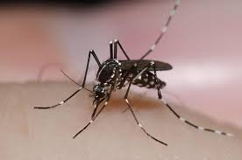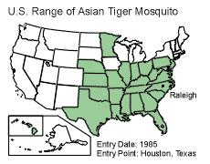
This is the time of year when Virginians are focusing on the traditional activities of summer, including an increase in time spent outdoors for everything from barbecues to hiking to athletic events and days at the beach. The Virginia Department of Health (VDH) and the Virginia Mosquito Control Association (VMCA) are working together to increase public awareness about another, less enjoyable part of summer--the threat that mosquitoes pose to their health.

Every summer, thousands of Virginians contact their local and state government officials about mosquito problems in their neighborhoods. In most cases the mosquitoes turn out to be Asian tiger mosquitoes, often found in containers of water on or near a citizen’s property.
“Asian tiger mosquitoes are small black and white mosquitoes and are known as ‘container breeders,’” explained David Gaines, PhD, Public Health Entomologist at the VDH. Their aquatic breeding habitats are artificial or natural containers that hold water. “A container holding a gallon of water and sitting in the shade will still hold water for months after the last rain,” said Gaines. “An Asian tiger mosquito larva can complete its development into an adult biting mosquito in as little as a tablespoon of water.”
Asian tiger mosquitoes are only active during daylight hours, but generally avoid open sunlight. This is a particular problem in neighborhoods that have a lot of shade and where the mosquitoes usually inhabit the foliage of a bush or shrub, waiting for a person or animal to walk by. Unlike other mosquito species, they are more likely to bite a person on the ankles, and the back sides of arms and legs.
“Asian tiger mosquitoes are a potential health threat in Virginia because they can transmit diseases that include West Nile virus, La Crosse encephalitis, and Eastern equine encephalitis,” explained Gaines.
Lane Carr, VMCA President, says the presence of mosquitoes easily can be reduced. “If you are having problems, focus on container habitats first. Inspect your property once a week, April through October. Be sure to look under decks or in tarps for hidden pockets of water. Reducing or eliminating the production of mosquitoes around your home will help you and your neighbors have a safe and enjoyable outdoor life this summer,” said Carr. In addition, the following tips will protect people from mosquito-borne diseases.
- Wear long, loose and light-colored clothing.
- If possible, stay indoors when mosquitoes are biting.
- EPA registered products that provide repellent activity sufficient to help people avoid the bites of mosquitoes: DEET, Picaridin, Oil of Lemon Eucalyptus or PMD, or IR3535. Check detailed instructions and precautions before using.
- Turn over or remove containers in your yard where water collects, such as old tires, potted plant trays, buckets and toys, etc,.
- Eliminate standing water on tarps or flat roofs.
- Clean out birdbaths and wading pools once a week.
- Clean roof gutters and downspout screens.
- Install or repair door and window screens.
For more information about prevention mosquito borne diseases call your local health department or visit the following web sites- -Virginia Department of Health
-Centers for Disease Control and Prevention
-American Mosquito Control Association
-Virginia Mosquito Control Association

