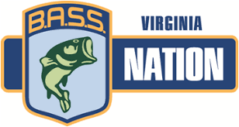

Mecklenburg County Youth Bass Masters
B.A.S.S. Nation of VA Inc.
Youth Membership Interest Form

Student Name _________________________________________________
Address: _______________________________________________________
City: _______________________________ State: ________ Zip: ________________
Student Contact phone numbers: Home: _____________________________
Cell: _______________________________
Student Email: __________________________________________
School: __________________________________________
Grade (2018-19 School Year):______
Date of Birth: ___________________________ Age: _____________
Parent/Guardian Name: ________________________________________________________________
Address: _______________________________________
City: _________________________________ State: _______ Zip: _______________
Phone Number(s): Home __________________________
Cell: ___________________________
Parent Email: ___________________________________________
Please mail this form to: Aleko Mangum, 4438 Highway 58, Buffalo Junction, VA 24529
If you have any questions, please contact:
Aleko Mangum, Mecklenburg County Coordinator
Email: mrmangum@gmail.com
Phone Number: 434-738-8574
--------------------------------------------------------------------------------------------------------------------
Dues paid on: ____________________

