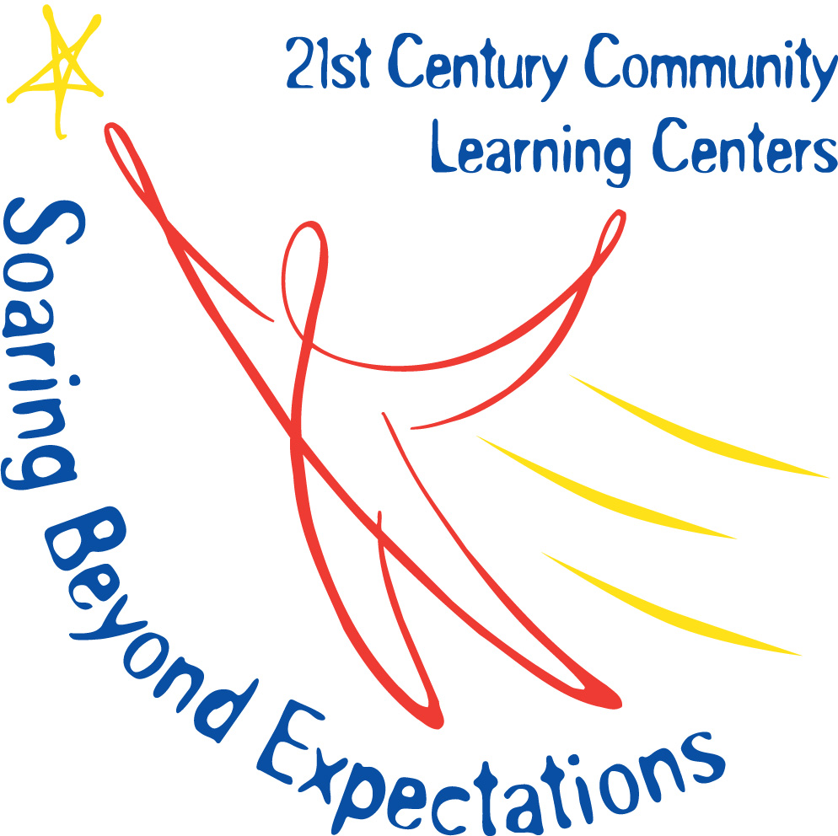

Chase City Elementary School
After-School Remediation and Enrichment Program

Parent/Student Information
Program Information

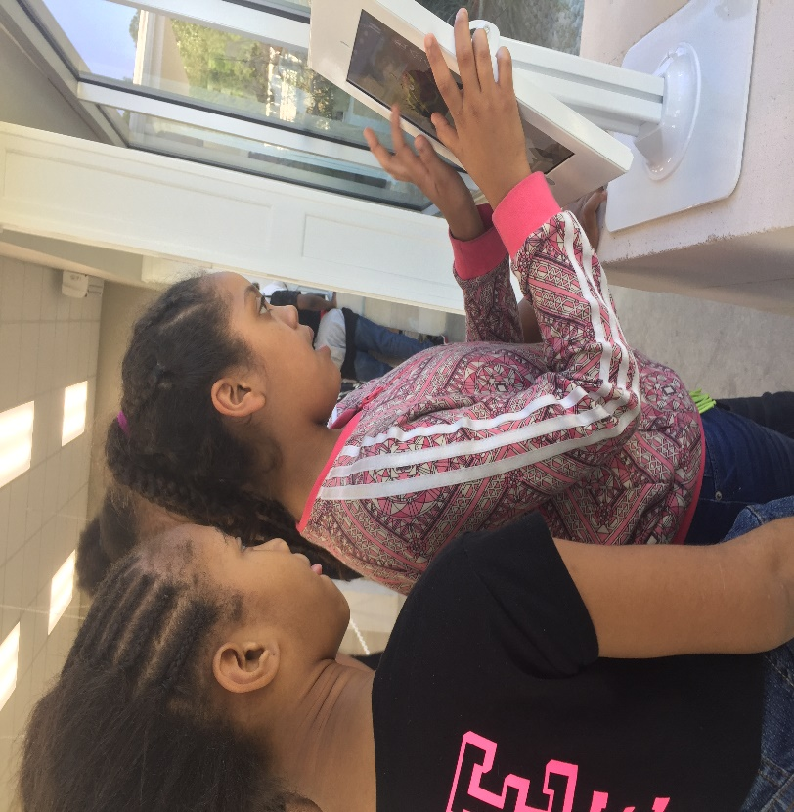
We are pleased to announce that Chase City Elementary School is a recipient of the 21st Century Community Learning Centers Grant again this year. The funding from this grant will be used to provide after-school remediation and enrichment. Students will receive Math and Reading remediation, help with homework, and hands-on enrichment activities designed to increase proficiency in core classes. The program will run Monday through Thursday from 3:35 to 5:30 following the school calendar. Students will be provided a nutritional snack each day. Transportation will be provided if students are unable to be picked up.

The program begins on Monday, September 10th and ends May 2nd following the school calendar. If school is closed or dismisses early, the after-school program is canceled for that day.

Attendance
In order for our program to be successful, your child’s attendance is important! Please plan for your child to attend the program everyday they are present at school. In order for remediation to be effective, your child must be present. Students who participate in intramural sports program, music program or another program need to check in with the instructional staff prior to going that program. Unless otherwise arranged with parents (in writing), students will report to their after-school class once the extracurricular activity is over. Student cannot attend the program the same day they are absent from school.
Note: Students activities off campus that go beyond the program hours must have pre-arranged transportation. The buses for the after-school program will not wait for students to return from other activities.
Student must attend the program a minimum of 45 days to participate in field trips.
Program Components

Snack: A snack is provided daily to all 21st CCLC program participants. The snacks offered are nutritious and meet Virginia DOE food standards.

Homework: After snacks, the first part of the program will be devoted to students starting their assigned homework. Homework assistance will last approximately 30 minutes. Understand that the primary focus of the program is remediation and enrichment, not homework. Students may not finish all homework assigned. Please check student homework planners to see what, if any, work needs to be completed.

Remediation: Students will receive remediation and intervention of targeted skills in reading (fluency, phonics, word study, comprehension) and math (number sense, computation, measurement, algebra concepts). Instructional staff will consult with classroom teachers on which topics or skills are being worked on in class and which skills to target for remediation. At times, computer/technology-based programs will be used for students to practice skills.

Enrichment: Students will engage is hands-on activities. These activities will allow students to apply and strengthen skills being remediated. Some activities include: yoga, gardening, culinary arts, STEM and art.
Note: Students must attend remediation classes to participate in the enrichment program.

Morning Tutoring

Small-group morning sessions are available Monday, Tuesday, Wednesday, Thursday and Friday mornings from 7:00 a.m.- 7:45 a.m. The morning program is specifically for tutoring and additional help with homework. Students who in this program are expected to participate in academic skills review. Students will be released to breakfast or homeroom at the end of morning tutoring.

Morning tutoring is not an early drop-off option for parents.
Transportation

Transportation is provided free of charge for students participating in the after-school program. Students will travel home via school bus each afternoon. Please note: Your child’s bus number for the after-school program may not be the same as his or her regular bus number. The after-school program will end at 5:30 promptly. We will do our best to make sure that buses roll out as close to 5:40 as possible. Please be patient with the drivers the first few days while they are determining the best routes. Remember that you must be at the bus stop when your child gets off the bus. The after-school registration indicated this—whatever procedure your child follows during the regular school day does not apply.
If you plan to pick your child up each afternoon, you will need to come to the main entrance to receive your child.
Whenever there is a change in what your child normally does (riding a different bus, another person receiving them at the bus stop), we will need a send written notification.

Behavior Expectations

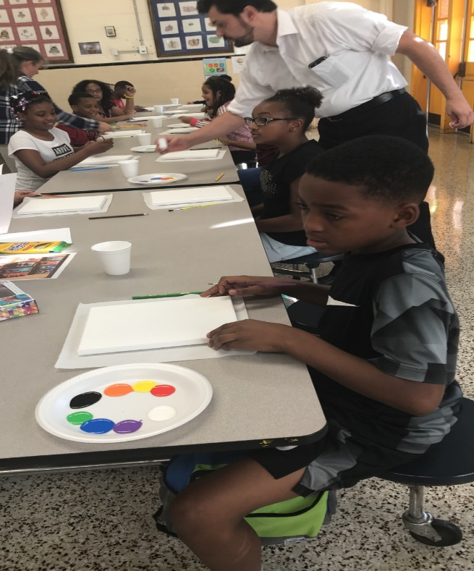
Students will receive marks if they break the rules of the program. The first mark is a warning. The second mark will result in a phone call home. The third mark will result in a one-week suspension from the program. If the student gets another 3 marks in one week, they will be removed from the program. Major incidences will be dealt with on a case-by-case basis.

We have a high respect for our busses and bus drivers. They are working overtime so that the program participants can get home. If a student receives a bus referral, they will be suspended from the bus for one week. If they get a third bus referral, they will be suspended from the after-school program bus for the rest of the year. Any student who accumulates multiple marks for disruptive behavior may result in students not being allowed to participate in field trips or other activities.
Contact Information
Frederick Taylor, Principal Brittany Griles, Site Coordinator
434-372-4770 434-372-4770
Donna Wilson, Data Manager Corlis Thompson, Grant Coordinator
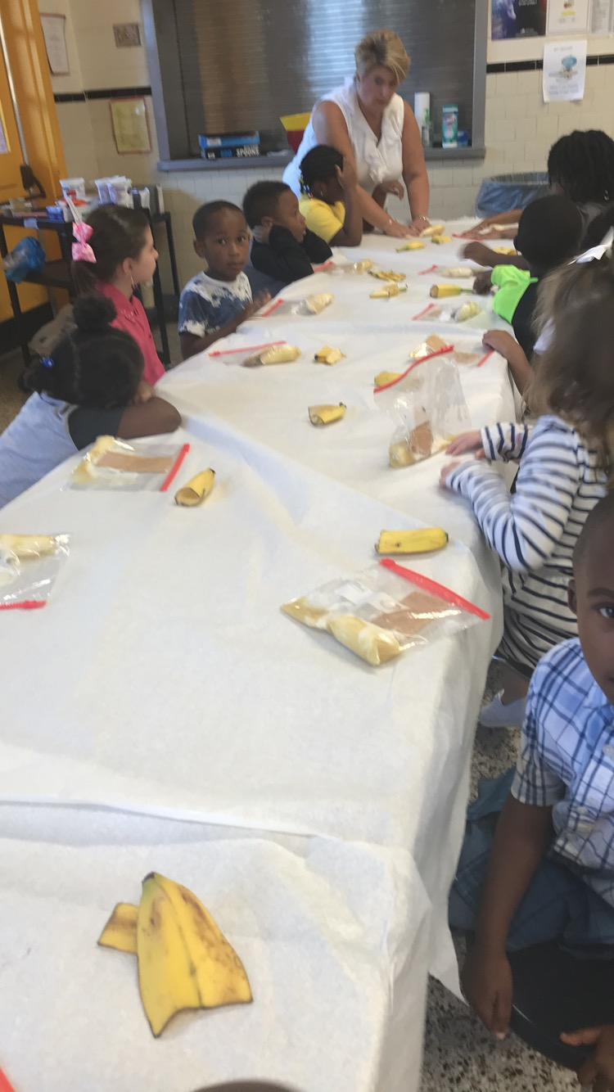
434-372-4770 434-447-3761
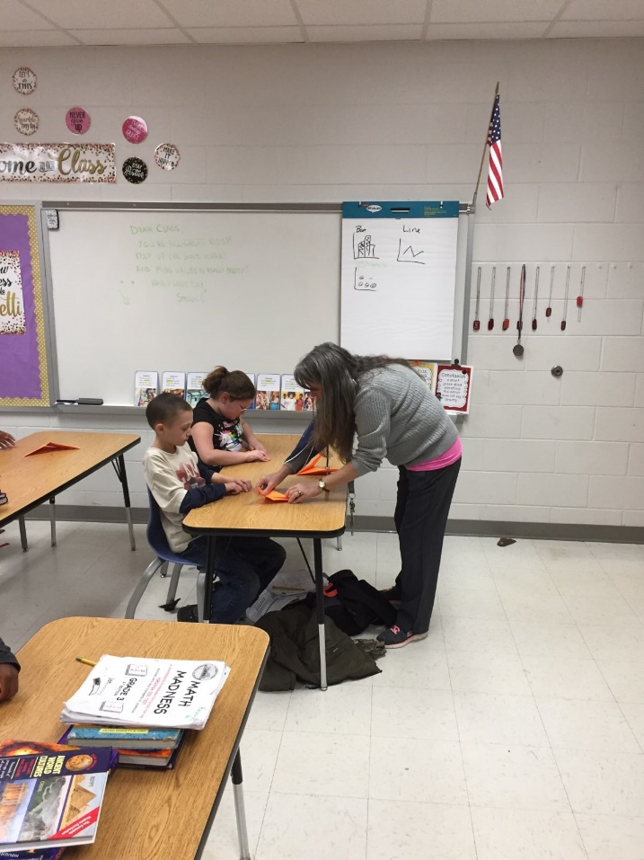

The 21st Century Community Learning Centers grant program supports the creation of community learning centers that provide academic and enrichment opportunities during non-school hours for students. This program is made possible by a Federal Grant from the U.S. Dept. of Education.
The program assists students in achieving state and local student standard in core academic subjects, such as reading and math; and offers students a broad array of enrichment activities that can complement their regular academic programs. In addition, the program offers outreach projects and services for families of participating children and the community.
All expenses are paid with the 21st CCLC grant. Students attend program for free.

