Name of Resource | Resource Provided By | URL
Dyslexia Awareness Module  module (40mins.) | VDOE  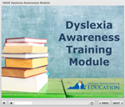 | http://www.doe.virginia.gov/special_ed/disabilities/learning_disability/dyslexia.shtml
Specific Learning Disability Supplementary Guide on Dyslexia: Frequently Asked Questions  booklet | VDOE  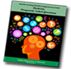 | http://www.doe.virginia.gov/special_ed/disabilities/learning_disability/dyslexia.shtml
Understanding Dyslexia: What are the effects of dyslexia?  Webpage/Infographic | National Center on Improving Literacy | https://improvingliteracy.org/brief/understanding-dyslexia-what-are-effects-dyslexia
Dyslexia Resources Roadmap  webpage | National Center on Improving Literacy | https://improvingliteracy.org/article/dyslexia-awareness-month-oct-2020
Dyslexia Basics: Fact Sheet  document | International Dyslexia Association | https://dyslexi aida.org/dyslexia-basics/
Dyslexia: Frequently Asked Questions  webpage | International Dyslexia Association | https://dyslexiaida.org/frequently-asked-questions-2/
Myths vs. Facts  infographic | National Center on Improving Literacy | https://improvingliteracy.org/sites/improvingliteracy2.uoregon.edu/files/briefs/understanding-dyslexia-myths-vs-fact.pdf
IDA Fact Sheets on Dyslexia  document | International Dyslexia Association | https://dyslexiaida.org/fact-sheets/
Dyslexia Handbook: What Every Family Should Know  handbook | International Dyslexia Association  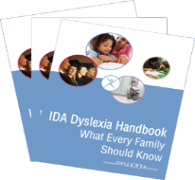 | https://dyslexiaida.org/ida-dyslexia-handbook/
Dyslexia in the Classroom: What Every Teacher Needs to Know  handbook | International Dyslexia Association  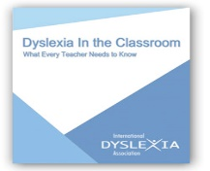 | https://dyslexiaida.org/dyslexia-in-the-classroom/
Dyslexia Toolkit  handbook | National Center for Learning Disabilities  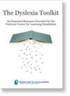 | https://www.readingrockets.org/sites/default/files/DyslexiaToolkit.pdf
What Does Good Instruction Look Like for Students with Dyslexia: A Systems and Classroom View  Webinar 1 hour | CORE Professional Learning Webinars | https://www.corelearn.com/free-webinar-what-does-good-instruction-look-like-for-students-with-dyslexia-a-systems-and-classroom-view/

