Name: For use with EpiPen® adrenaline (epinephrine) autoinjectors
ACTION PLAN FOR
www.allergy.org.au
Anaphylaxis

Date of birth:

Photo
Confirmed allergens:

Family/emergency contact name(s):
1. Mobile Ph: 2. Mobile Ph:

SIGNS OF MILD TO MODERATE ALLERGIC REACTION
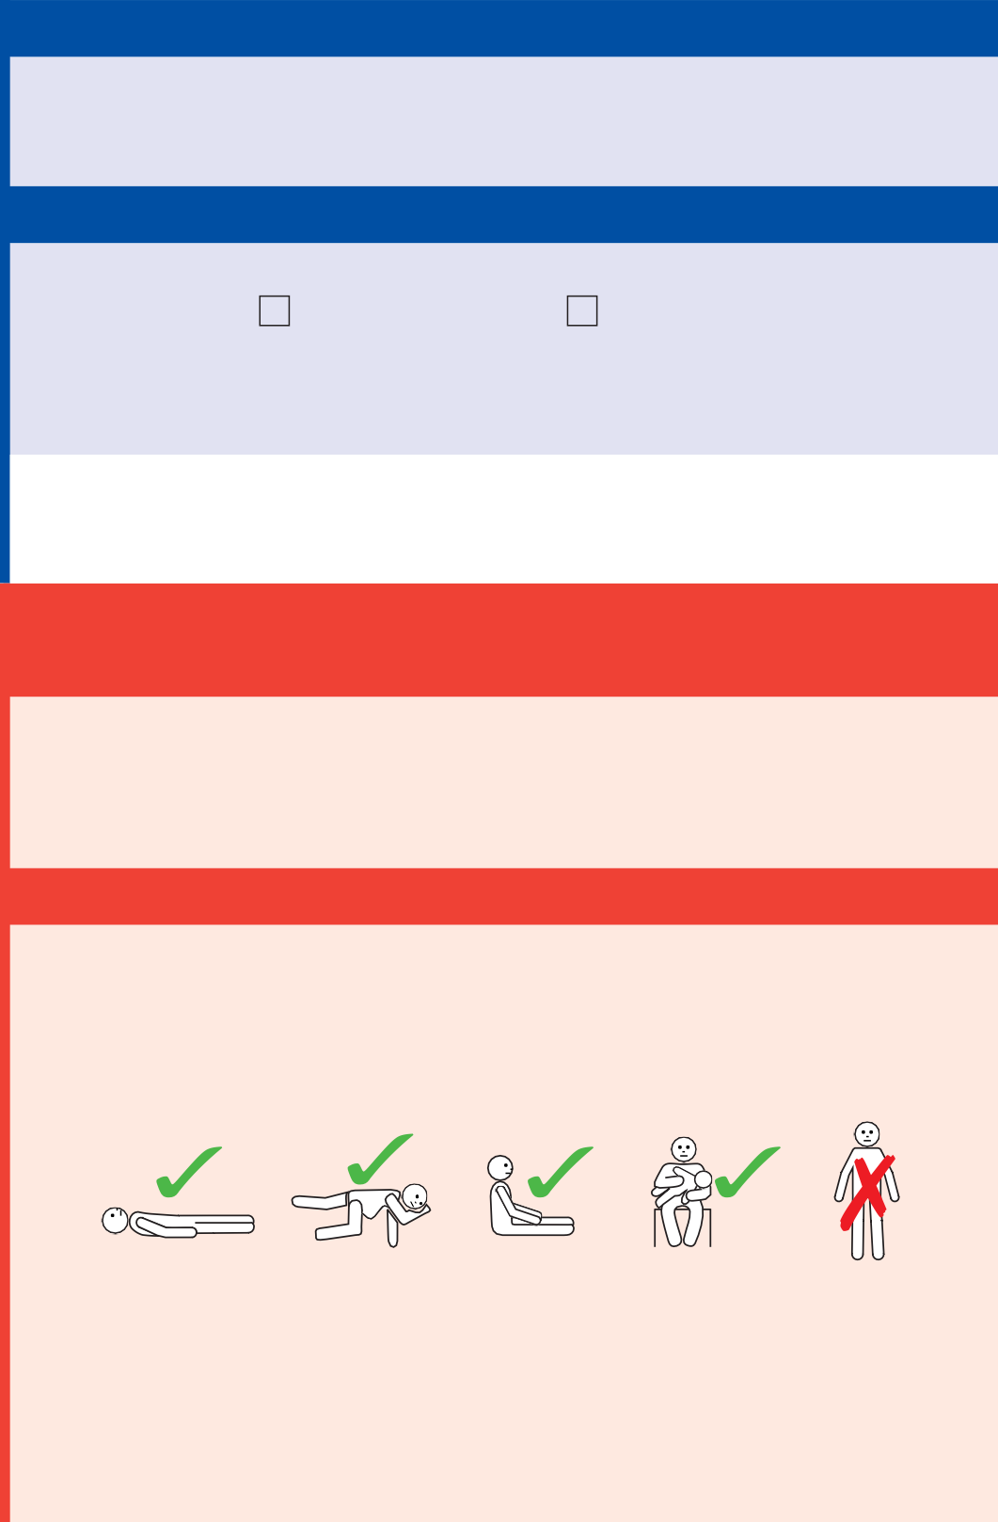
- Swelling of lips, face, eyes • Tingling mouth
- Hives or welts • Abdominal pain, vomiting - these are signs of anaphylaxis for insect allergy

ACTION FOR MILD TO MODERATE ALLERGIC REACTION
- For insect allergy - flick out sting if visible
- For tick allergy seek medical help or freeze tick and let it drop off
- Stay with person, call for help and locate adrenaline autoinjector
- Give antihistamine (if prescribed)
- Phone family/emergency contact
Mild to moderate allergic reactions (such as hives or swelling) may not always occur before anaphylaxis

WATCH FOR ANY ONE OF THE FOLLOWING SIGNS OF ANAPHYLAXIS (SEVERE ALLERGIC REACTION)

Plan prepared by doctor or nurse practitioner (np):

The treating doctor or np hereby authorises medications specified on this plan to be given according to the plan, as consented by
- Difficult or noisy breathing
- Swelling of tongue
- Swelling or tightness in throat
- Wheeze or persistent cough
- Difficulty talking or hoarse voice
- Persistent dizziness or collapse
- Pale and floppy (young children)

the patient or parent/guardian.
Whilst this plan does not expire, review is recommended by DD/MM/YY
Signed: Date:

ACTION FOR ANAPHYLAXIS
- LAY PERSON FLAT - do NOT allow them to stand or walk
- If unconscious or pregnant, place in recovery position
- on left side if pregnant, as shown below
- If breathing is difficult allow them to sit with legs outstretched
- Hold young children flat, not upright

- GIVE ADRENALINE AUTOINJECTOR
- Phone ambulance - 000 (AU) or 111 (NZ)
- Phone family/emergency contact
- Further adrenaline may be given if no response after 5 minutes
- Transfer person to hospital for at least 4 hours of observation IF IN DOUBT GIVE ADRENALINE AUTOINJECTOR
Commence CPR at any time if person is unresponsive and not breathing normally

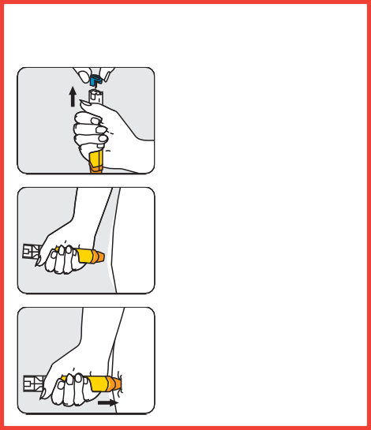
How to give EpiPen®
Form fist around EpiPen®
1
and PULL OFF BLUE SAFETY RELEASE
2
Hold leg still and PLACE ORANGE END against outer mid-thigh (with or without clothing)
3
PUSH DOWN HARD until
a click is heard or felt and hold in place for 3 seconds REMOVE EpiPen®
ALWAYS GIVE ADRENALINE AUTOINJECTOR FIRST, and then
asthma reliever puffer if someone with known asthma and allergy to food, insects or medication has SUDDEN BREATHING DIFFICULTY (including wheeze, persistent cough or hoarse voice) even if there are no skin symptoms
Asthma reliever medication prescribed: Y N
Note: If adrenaline is accidentally injected (e.g. into a thumb) phone your local poisons information centre. Continue to follow this action plan for the person with the allergic reaction.
EpiPen® is prescribed as follows:
- EpiPen® Jr (150 mcg) for children 7.5-20kg
- EpiPen® (300 mcg) for children over 20kg and adults
© ASCIA 2021 This plan was developed as a medical document that can only be completed and signed by the patient's doctor or nurse practitioner and cannot be altered without their permission.

