Parent-Student

Handbook
South Hill Elementary School
1290 Plank Road
South Hill, Virginia 23970
434-447-8134

South Hill Elementary School

1290 Plank Road

South Hill, Virginia 23970

September 12, 2022

Dear Families and Students,
Welcome to South Hill Elementary School! I am excited to be joining the team at SHE this year! I also know that you all are excited for a brand new school year too! On behalf of the faculty and staff, we are delighted to have you as a part of the South Hill Elementary School team! We are looking forward to continuing our school’s successes, and we look forward to the opportunity to build relationships with each of you. Our goal is to help each child and family have a productive and successful school year. We are here to help each student work to reach their full potential while growing as an individual.
As we prepare for the exciting learning opportunities expected in the upcoming school year, please take time to read over the Parent/Student Handbook with your child. The Parent/Student Handbook is provided to answer questions about the policies and procedures of Mecklenburg County Public Schools as well as the expectations and activities specific to our school. I urge you to understand where your child’s handbook can be found online. It will be helpful as a reference as questions arise throughout the school year.
Please remember that your active participation and daily attendance is necessary for the success of your child. Let your child know that school is important through your words and actions. When home, community, and school work as a team, we can expect great things for and from our children. I encourage you to communicate regularly with your child’s teacher, and attend meetings and conferences. Your support is wanted and needed. If we can be of any assistance to you at any time, please feel free to call us at 434-447-8134. We look forward to serving you and challenging each student to make this their best year yet!

Educationally yours,
Lauren A. Thompson, Principal

CONTACT INFORMATION
Attendance Questions | Contact Jo Clary, Secretary  South Hill Elementary School  434-447-8134
Discipline Questions | Conferences may be set up with the teacher(s) or administration of  South Hill Elementary School 434-447-8134
Special Education – Current Students | Contact Melissa Chumney, Assistant Principal (Pre-K - 2nd SPED)  or  Amanda Shook, Assistant Principal (3rd - 5th SPED)  South Hill Elementary School  434-447-8134
Special Education – New Referrals | Contact Rita Huston, School Counselor  South Hill Elementary School  434-447-8134
504 Plans | Contact Jeanne Adams, School Counselor  South Hill Elementary School  434-447-8134
Transportation Questions | Transportation concerns can be reported to the principal of the school involved or to the supervisor of transportation, Mrs. Donna Conner the Bus Shop 434-738-6771.
Homebound Instruction | Ms. Jeannie Garner, Central Office  434-738-6111
Pre-School Information | Mrs. Amy Hite, Central Office  434-738-6111
School Food Services | Shawna Felts, Cafeteria Manager  South Hill Elementary School  434-447-8134
Superintendent of Schools | When you feel that particular problem or situation needs the attention of the Superintendent of Schools, contact Ms. Paula Giamatteo, Superintendent Secretary at the School Board Office  434-738-6111
Mr. Paul Nichols, Division Superintendent Dr. Scott Worner, Assistant Superintendent
Mrs. Robin Moore, Supervisor of School Food Services
Mrs. Mary Hodges, Director of Special Education

School Board Office
Phone #: 434-738-6111 Fax #: 434-738-6679

School Board Garage/School Board Maintenance Shop
Mrs. Donna Conner, Transportation Supervisor
Phone #: 434-738-6771 Fax #: 434-738-0100

South Hill Elementary School Statement
South Hill Elementary School believes that by fostering a positive learning environment, we empower everyone to achieve and succeed. Through teamwork, students and staff will be valued, supported, and challenged to reach their highest potential.

School Hours
The school day begins at 9:00 a.m. and ends at 3:30 p.m. each day unless otherwise noted on the MCPS Calendar. Parents that choose to drop off students in the morning may do so starting at 8:30a.m. In the afternoon, students will be dismissed as follows:
3:20 Car riders will begin dismissing
3:30 Buses will begin loading

Bell Schedule
Note: The required instructional day for elementary students in Mecklenburg County Schools begins at 9:00 a.m. and ends at 3:30 p.m.
8:30 a.m Car and bus riders will begin unloading. Students will report to their homerooms. Breakfast will be available for pickup in the cafeteria.
9:00 a.m. Students are to be in homeroom classes. Tardy bells ring.
Morning announcements are made. Students arriving to school after this time will be
marked tardy.
If a student arrives after 9:00, parents must sign in students in the main office and list the reason for tardiness.
3:20 p.m. Students are dismissed. A change in time or routine way of going home must be accompanied by a written note from the parent submitted no later than 1:30. We will follow the child’s normal routine without a note from the parent. We will not accept changes to bus transportation.

Visitors.
- Visitors will report to the office.
- Conferences and meetings with teachers must be by appointment. No drop-in visits will be permitted.
- Refer to MCPS Elementary Student Handbook for more details on visitor procedures.

Transporting Students To and From School
Parents may choose to drop off and pick up students or allow them to ride the bus to and from school following the stated procedures for South Hill Elementary School. If there are any questions, please feel free to ask. Staff will be outside to assist.

Carpool Loop Procedures
- Enter the parking lot in front of the building.
- Make the first right turn.
- Turn right into the carpool loop and follow it all the way around.
- Turn right to exit the carpool loop.
- Proceed to the front of the building to the drop off/pick up zone. Please pull down as far as you can to allow as many vehicles to drop off/pick up as possible.
- Continue forward and make the second left (at the stop sign) to exit.
- IF YOU ARE TURNING ON TO PLANK RD.--You may turn right or left.
IF YOU ARE TURNING ON TO W. DANVILLE ST.--You may turn right only. Left turns on to Danville St. are prohibited from 8:15 a.m. to 9:15 a.m. and from 3:00 p.m. to 4:00 p.m.

If you have any questions concerning our carpool loop procedures, please feel free to ask. There will be staff members to help the first few days of school.

Morning Drop-Off
- Please refrain from stopping and getting out of your vehicle as this impedes traffic.
- If your student needs assistance getting out of the car due to child locks on the door, a staff member will be available to assist.
- Once your student has gotten out of your vehicle and safely on the sidewalk, please follow the exit traffic pattern to leave the parking lot.
- Parents are encouraged to follow this procedure and refrain from parking in the lot to drop off their students.

Afternoon Pick-up
- All parents are expected to use the car rider line to pick up their students.
- Parents are not permitted to walk up and sign out students.
- Please refrain from stopping and getting out of your vehicle as this impedes traffic.
- Do not park in the pick-up line.

Bus Rider Procedures
Refer to the MCPS Elementary School Handbook for bus rules and regulations.

Procedure for Making Changes to Student Transportation
- Requests for changes to buses will not be granted.
- Any parent who picks up his/her child before 3:30 p.m. is required to report to the office and sign the child out. You must present a photo ID .
- Any changes from bus to car must be made by the parent or legal guardian in writing prior to 1:30 p.m.
- For your child’s safety, NO changes will be accepted after 1:30 p.m.
- Changes CANNOT be made over the phone!
- Please refrain from making frequent changes to your child’s transportation as this creates a safety concern for your child.

Procedures for Signing Students out of school (During the School Day)
Parents, Legal Guardians, or other designated adults must come into the office.
*Emergency cards are flagged for any students that may have custody or other legal orders of which the school has been made aware. Parents are responsible for providing documentation to the school.
- A valid photo ID must be presented, even if the person picking up is the parent or legal guardian. Our student sign out system will not allow anyone to sign a student out without valid state-issued identification. Make sure that you bring your driver’s license or photo identification with you each time.
- Once a request has been made for pick-up of a child, the Emergency Card must be checked.
*If the person picking up the child is not on the Emergency Card, the school must have received prior written notice from the parent or legal guardian before dismissing the child.
**If the person picking up the child is not on the Emergency Card and the school has NOT received prior written notice, the office staff must contact the parent and have verbal permission before dismissing the child.
- The adult must sign the student out using the computer.
- The child will then be called to the office for dismissal. No students will be called up to wait for a parent to arrive.

HEALTH and WELLNESS INFORMATION

Please remember
Wash your hands often with soap and water for at least 20 seconds.
Use hand sanitizer with at least 60% alcohol if soap and water are not available.
Avoid touching your eyes, nose, and mouth.
Cover your mouth and nose with a tissue when you cough or sneeze or use the inside of your elbow

Symptoms Requiring Absence from School
- Active vomiting or diarrhea
- Fever/chills/generalized body aches
  - Fever threshold will constitute 100.0 degrees Fahrenheit or higher.
  - Temperatures with body aches and other symptoms likely indicate acute illness.
  - Fever free without the use of fever reducers such as: Tylenol, ibuprofen, Motrin, etc.
- The first 24 hours of antibiotic treatment (including strep throat, pink eye, etc.)
- Undiagnosed, new and/or untreated rash/skin condition (i.e., generalized hives, wounds with purulent drainage, etc.)
- Anyone with a doctor’s note requiring an individual plan of care to stay home

Allergies
It is important that all school personnel know of any type of allergy your child has, such as bee stings or foods. This information should be provided to the school nurse, who will see to it that the appropriate personnel are notified. If your student is transported to school by bus, the bus drivers will also be provided with this information.
Food Services must have a statement from your physician documenting the specific food allergy and acceptable substitutes in order to make accommodations within the National School Breakfast and/or Lunch Program.

Injuries and Illness
If it is determined that a student is ill or has sustained an injury that requires more than assistance given in the classroom, that student will be brought to the clinic immediately for further evaluation by the school nurse. If parent contact is necessary, every effort will be made to notify the parent or responsible party listed on the student’s emergency card.
It is imperative that the information on the student’s emergency card be kept current. In most cases, your child will need to be picked up by a parent or designee so that a decision can be made on the treatment needed. Adequate facilities and staffing are not available to allow us to isolate sick or injured children for an extended amount of time; therefore, your prompt response is essential.
If a student is ill and requires extended time out of school, parents must call the school to request homebound instruction. A licensed physician must indicate in writing that the child cannot attend school, in order for a child to qualify for this service.

Medication: Administration and Storage
See MCPS Elementary Student Handbook for details.

FOOD SERVICES

Breakfast and Lunch
Outside food and drink will not be allowed. ALL students are eligible for free breakfast and lunch. If an additional lunch or milk is purchased, the prices are listed below. Breakfast will be served from 7:45 a.m. to 8:15 a.m. Lunch will be served following the lunch schedule listed.

All students received a free breakfast and lunch.
These prices are only if purchasing a second meal.
Breakfast: Students - .80 Adult - Ala Carte Price
Lunch: Students - $2.25 Adults - $4.00
Students are not allowed to bring bottled or canned soft drinks to school.
Students are not allowed to use the snack and soda machines in the rotunda.

Every student is expected to order lunch, unless he/she has brought a packed lunch from home.
Students will be allowed to purchase extra items if they have money on their accounts. Money can be added to accounts by sending in cash or check in advance or adding money using myschoolbucks.com. No money will be taken during breakfast or lunch service.
Parents and visitors will be permitted to come in for lunch following proper check in procedures.
For the convenience of our parents, students, and staff, school breakfast and lunch menus will be sent home every month by the student and also may be found on the school’s website at https://mcpsweb.org and on our Facebook page.

Lunch Schedule
11:00-11:30 PreK
11:30-12:00 Kindergarten
11:10-11:40 1st Grade
11:40-12:10 2nd Grade
12:00-12:30 3rd Grade
12:10-12:40 4th Grade
12:35-1:05 5th Grade

Classroom Celebrations
Holiday parties will be scheduled by classroom teachers. All snacks and drinks should be store bought and individually wrapped. Individual snacks and drinks can also be brought in for your child’s birthday, contact your child’s teacher directly to arrange a time. All snacks and drinks will be served outside of lunch hours.

INSTRUCTION
Parent Portal will be available to parents this school year to view student progress online. If you do not have a Parent Portal account set up, please contact Rita Huston at South Hill Elementary School at 434-447-8134.

Homework
Homework for K-1 will consist of 30 minutes for Reading and written work combined.
Homework for 2-5 will consist of 60 minutes for Reading and written work combined.
These times are approximate for students. Some students may take more time and some may take less time.

Accelerated Reader
Accelerated Reader (AR) is a computerized reading program that has been proven to be a very effective tool in improving reading in the classroom and increasing library circulation. The AR program provides students the opportunity to practice reading at their level, establish goals for their reading, and aid in the development of a love for reading and learning. As a motivator, students receive points for their participation in the program. Students are eligible to attend the end of the marking period celebrations for meeting the determined number of points. One additional benefit to this program is that a reading level is determined according to the progress a student makes while demonstrating mastery of various comprehension levels. Please encourage your child to read every day. Students will be able to access AR at home.

Virtual Learning Expectations: IN THE EVENT OUR SCHOOLS ARE CLOSED

Student
- Follows MCPS CODE of CONDUCT in class and in remote settings.
- Participate in classes each day.
- Complete and submit all assignments online following due dates from teachers..
- Work to the best of your ability and follow the Honor Code.
  - For Assessments: “I affirm that I will not give or receive any unauthorized help on this exam, and that all work will be my own.”
  - For Graded Assignments: “I affirm that I have not given or received any unauthorized help on this assignment, and that this work is my own.”
  - For Group Projects: “I accept responsibility for my role in ensuring the integrity of the work submitted by the group in which I participated.”
- For extra support, communicate with your teachers through the @mcpsweb.org email account and attend office hours.
- Keep your parents informed of any problems that you may be having with instruction.
- Tablet/Laptop Devices should be brought to school each day.
  - Ensure that all devices are taken care of, charged, and ready for use.
  - Students should keep devices clean, secure, and charged at all times.
  - Keep all passwords and login information easily accessible and secure.
- Students are expected to follow this process when logged-in to a remote session.
  - Mute button should be enabled and accessible to participate
  - Video feature should be on at all times during live remote sessions (dress appropriately)
  - Language should be clearly spoken and absent of profanity
  - Eating or drinking during the session should not occur
  - Cell phones (unless it’s being used for the remote session) should not be part of the learning environment)
- Communicate frustrations or stressful situations to your teacher or parent as soon as possible.

Parents
- Notify school if your child will be absent from any remote class each day - attendance is being taken.
- Assist in preparing a space at home for remote learning and completing any assignments for class that is free of distraction.
- Ensure that all devices are taken care of, charged, and ready for remote learning.
- Communicate with the teacher to get a class schedule and expectations.
- Help your student organize due dates for work and study for assessments.
- Assist in keeping passwords and login information available and in a secure location
- Ensure that students complete all assignments and activities on time.
- Parents are expected to monitor their student’s progress throughout the school year by arranging appointments during office hours.
- Parent Portal should be monitored regularly for grades.
- Contact your child’s teacher directly via email, REMIND text, or call the school and the secretary will pass along your message to answer questions about the course that you may have.
- Parent Conferences can be made by appointment by contacting the teacher/school.
- Monitor your student’s frustration/stress level and offer opportunities to talk about their feelings.

TESTING
SOL Windows are September 12-September 30, and May 22-June 16. Students in grades 3-5 will take SOL tests within this window.
Expedited Testing for Spring testing only: The state Board of Education says that elementary and middle school students who fail Standards of Learning (SOL) tests by narrow margins (375-399) may be retested before the end of the year — provided that school divisions first secure parental permission.

Division Testing:
Reading and Math will be assessed through CIP benchmarks, Student Growth Assessment, STAR Diagnostic Assessment Science and History will be assessed using CIP benchmarks.

Please make every effort to have your child at school on time every day prior to and during testing and allow him/her to remain at school for the entire day. It is extremely important that appointments, vacations/trips, etc., be scheduled at times that do not interfere with the school day, as there will be ongoing daily instruction and review to prepare the students for testing.

BEHAVIOR

Standards of Conduct
Please refer to the MCPS Elementary Student Handbook for more information.

School Wide Behavior Expectations
Students and parents should familiarize themselves with the division policies on student attendance, discipline, and bus conduct. The following rules are established for students:

 | Hallway & Transition | Classroom | Bathroom | Cafeteria | Playground | Bus
Safe | *Walking feet  * Eyes forward  * Stay in line | *Listen  *Follow directions the first time they are given.  * Ask for help when needed. | *Walking, standing and sitting correctly  *Keep hands, feet, and belongings to myself | *Safe walking *Sitting with feet under the table | *Stay with my class  *Use playground equipment properly  *Keep hands, feet, and belonging to myself | *Stay in assigned seat  *Sit correctly  *Stay seated for entire ride  *Use quiet voices
Hard Working | *Walk directly to my designation | *Be ready to learn  *Be present and focused | *Be timely  *Go, flush, wash, exit | *Eat neatly | *Quiet lines | *Sit with back against the seat and feet on the floor  *Talk quietly with your seat partner
Accountable | *Mind your own business  *Carry my own belongings  *Walk directly to my designated area | *Clean up after myself.  *Attend class daily and on time  *Be prepared with all necessary materials | *Responsible for myself  *Report messes | *Clean up after myself  *Throw away my trash and dump my tray | *Line up when called  *Follow established game and playground rules  *Manage my behaviors  *Move away from conflict  *Report potential problems to a teacher | *Follow established bus rules  *Manage your own behaviors  *Report potential problems to a bus driver  *Keep belongings in book bag during ride
Respectful | *Walk quietly in a single, straight and silent line so others can continue learning and working  *Respect the space of others  *Walk to the right side of the hall | *Accept feedback and discipline from staff by listening, asking questions, and following directions the first time. | *Allow for the privacy of others  *Respectful words | *Listen to adults the first time asked  *Keep food on my tray or in my mouth  *Keep hands, feet, and belongings to myself | *Listen to adults the first time  *Respectful conversation  *Sportsmanship | *Listen to adults the first time  *Respectful conversation  *Keep hands, feet, and belongings to self.
Kind | *Silent greeting to adults and other students  *Use kind expressions | *Encourage others | *Keep the area clean | *Use table manners | *Have fun  *Include others | *Keep it clean  *Keep noise level down

Bullying
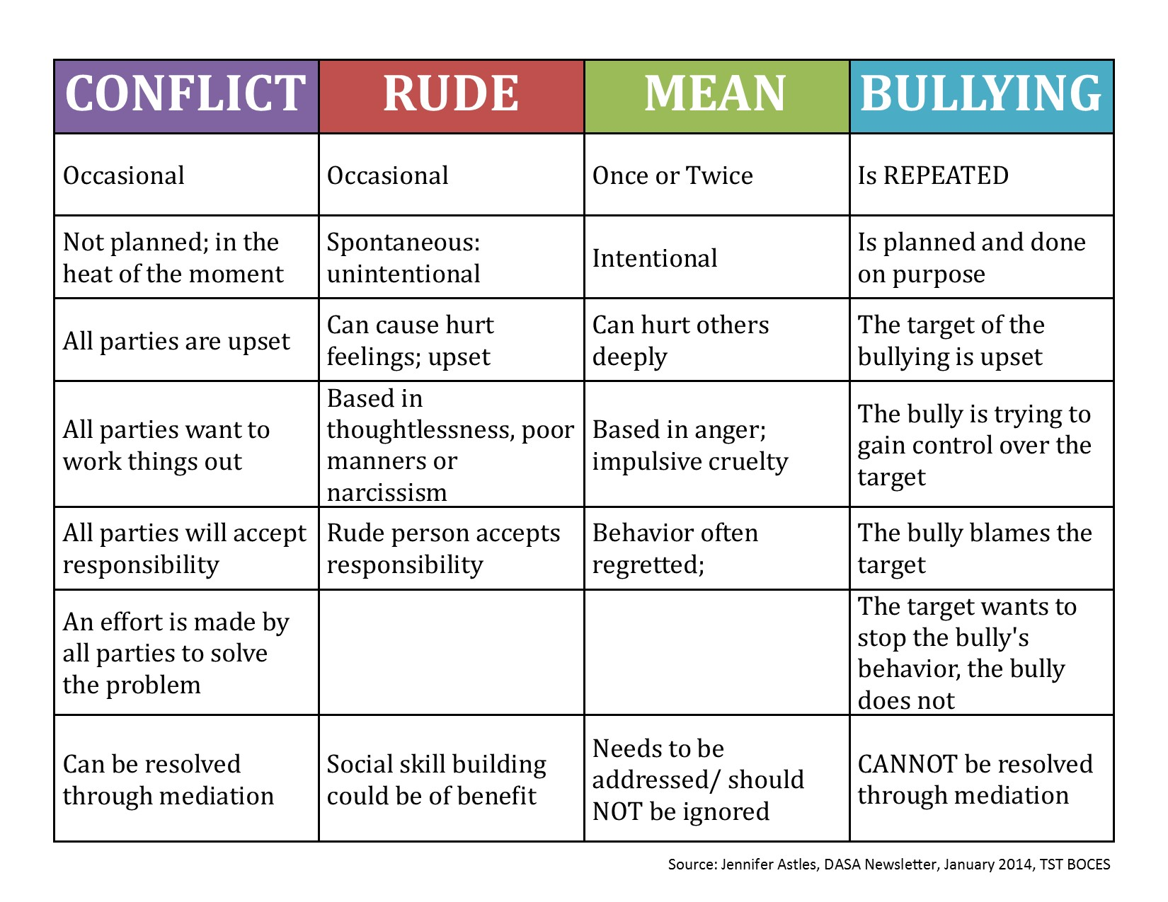
Any student determined to exhibit bullying behavior will be required to attend two (2) sessions with the School Counselor. Parents will be notified by the School Counselor.

Search of Student Property
Students are encouraged not to bring items that are not part of his or her academic program. South Hill Elementary School and Mecklenburg County Public Schools cannot be responsible for such items if they are lost or stolen. Large sums of money should not be brought to school. Students should not offer or accept money from other students. The administration may search a student’s desk or book bag if there is a reasonable suspension that articles or materials exist which cause injury to the student or pose a threat to others or to the maintenance of discipline and order in the school.
Standards of Learning (SOL’s)
Parents may access the Virginia Standards of Learning at www.doe.virginia.gov.
.

Limited English Proficient Students
School divisions receiving federal funds to provide LEP programs must inform the parents of LEP students of the following:
- the reasons for the identification of their child as limited English proficient and in need of placement in a language instruction educational program
- the child’s level of English proficiency, how such level was assessed, and the status of the child’s academic achievement
- the methods of instruction used in the program in which their child is, or will be participating, and the methods of instruction used in other available programs, including how such programs differ in content, instructional goals, and the use of English and a native language in instruction
- how the program in which their child is, or will be participating will meet the educational strengths and needs of their child
- how such program will specifically help their child learn English and meet age-appropriate academic achievement standards for grade promotion and graduation
- the specific exit requirements for the program, including the expected rate of transition from such program into classrooms that are not tailored for limited English proficient children, and the expected rate of graduation from secondary school for such program
- in the case of a child with a disability, how such program meets the objectives of the individualized education program of the child
- information pertaining to parental rights that includes written guidance detailing
  - the parents’ right to have their child immediately removed from such program upon their request and
  - the options that parents have to decline to enroll their child in such a program or to choose another program or method of instruction, if available.
- information pertaining to parental rights that includes written guidance assisting parents in selecting among various programs and methods of instruction, if more than one program or method is offered by the division

COMMUNICATION

Conferences
Good communication between parents and school personnel is important for the development of a meaningful educational program for children. A valuable way to gain knowledge of your child’s development is through parent/teacher conferences. Teachers will be happy to talk about the progress your child is making. Face-to-face meetings must be scheduled in advance with the teachers. No drop-in meetings will be allowed.

Folders
On Monday, your child’s teacher will send home the previous week’s work. These papers give you your best opportunity to monitor your child’s progress and potential report card grade.

Remind App
Teachers and Administrators will use the Remind App as one way to communicate with parents. This app can be uploaded on your mobile device for easy access. The app also allows teachers and administrators to send text messages to parents. This system interacts with our student database to determine phone numbers to call. If your number has changed, it is important that you notify the school so we can make changes to the database. Please make sure we have accurate information at all times.

Infinite Campus Automated Calls
Messages will also be sent home using the automated call system. Calls may be sent from the School level using the number 434-447-8134 or from the Division level using the number 434-738-6111. This system interacts with our student database to determine phone numbers to call. If your number has changed, it is important that you notify the school so we can make changes to the database. If your mailbox has not been set up or your mailbox is full, you will not receive the message. Please make sure we have accurate information at all times.

Emergency Procedure
See MCPS Elementary Student Handbook for details.

Emergency Information
Accurate information concerning each child is a must. The emergency card will be sent home on the first day and must be completed by parents and returned to the child’s homeroom teacher. Please make sure you provide complete (detailed) information regarding phone numbers where you, or a responsible adult, may be reached in an emergency situation. These numbers should be updated when they change. Each child’s Emergency Card is kept in the office and is used by our school’s staff for the purpose of contacting a parent or responsible adult in an emergency.

Facebook
Updates and other information is shared on our school Facebook page.

School Website
Check Out South Hill Elementary School’s Web Page! Please visit our web page at: https://mcpsweb.org/?page_id=28723 .

